Volume XV, Number 3
Minutes of the Faculty Senate Meeting
November 11, 2021

- Call to Order and Roll Call

The meeting was called to order by President Kelly Homan. Roll was called by Secretary Dave Westenberg. Those whose names are grayed out below were absent.

Lana Alagha, Julia Alexander, Venkat Allada, Stuart Baur, Matthew Burmeister, Marco Cavaglia, Jeff Cawlfield, Amitava Choudhury, Steve Corns, Kathryn C. Dolan, Cassie Elrod,
Scott Miller for William Fahrenholtz, Mahelet Fikru, Darin Finke, Mark Fitch, Michael Gosnell, Sarah Hercula, Kelly Homan, Ali Hurson, Matt Insall, Ulrich Jentschura, Kurt Kosbar, Umit Koylu, K. Krishnamurthy, Bih-Ru Lea, Kelly Liu, Ashok Midha, Parthasakha Neogi, Jorge Porcel, Prakash Reddy, Melissa Ringhausen, Paul Runnion, Chaman Sabharwal, William Schonberg, Sahra Sedigh Sarvestani, Shannon Fogg for Kathleen Sheppard, Jeff Smith, Vahe Permzadian for Nancy Stone, Shoaib Usman, Jee Wang, David Westenberg, Daniel Willis, Maciej Zawodniok

II. Approval of Minutes

The minutes of the October 21 meeting were distributed prior to this meeting.
A motion was made to approve the minutes.
Motion passes.

III. Administrative Reports

- Chancellor’s Report

Chancellor Dehghani presented and reminded everyone that if they see a student struggling, reach out and contact appropriate offices that might help.

The Kummer Institute Foundation Board of Directors met on November 5th and approved S&T to move forward with the following initiatives:
- Ignition grants for research and digital learning/pedagogical initiates
- Student academic support services to improve retention and graduation
- Base funding for Kummer endowed faculty positions
Everything is in place for the arrival district and all of the money is secured. The project is slated to start in May of 2022.

- Provost’s Report
Provost Potts presented and mentioned that this is the time of year when faculty, staff and students are feeling stretched so be kind to each other.

There are four Dean searches getting ready to start. S&T will be assisted by the search firm Bufkin and Baker. Each search committee with have two co-chairs and broad representation from each college. There will be a sitting or former department chair on each committee as well.

A graduate student survey went out and the results will be acted upon.

For more data and analysis regarding Missouri S&T, please visit https://data.mst.edu/.

IV. President’s Report

Kelly Homan presented and reported that the Intercampus Faculty Cabinet (IFC) met on November 5th via Zoom. Topics discussed included;
  - Policies for Faculty Review of Administrators, specifically MU Chancellor and UM System President.
Discussion as to whether Mun Choi should be reviewed as the MU President or the UM Chancellor was brought up and is still being discussed.
  - Shared Governance working group: continued progress.
  - Legislative Update
    - State-level budget looks good
    - Interests include transformative projects and Bright Flight for Higher Ed

IFC also met via Zoom with President Choi on November 10th. Topics discussed included;
- Meeting focus: Criteria-based Salary Reductions
- HR-720 Policy on Salary Reductions for Faculty and Other Academic has been rescinded.
- Existing CRR Policy statements in force are
CRR 310.015: Procedures for Review of Faculty Performance, and
CRR 320.030: Delegation of Authority subsection F = Criteria–Based Salary Reductions for Tenured Faculty.
Most recent refinement of CRR 310.015 in 2017, after wide, deliberate vetting process
Origin of CRR 320.030 dates to 1967.
- IFC seeking clarity and linkage between the two issues and clarity of process.

Kelly Homan also presented for the Administrative Review Committee (ARC). Faculty Senate will be asked to vote on the positions suggested for review at the January meeting. The tentative timeline is;
Action | Time
Review list to faculty senate for approval | January 20
Job descriptions | January 28
Development of questionnaires
Questionnaires to FS for review/approval | February 17
Statement of accomplishments due | February 25
Review of administrations | March 7 - March 23
Results to FS officers | April 28
Final report to FS | June 9

V. Campus Reports

- Staff Council
No report.

- Student Council
Amanda Aiken presented and discussed that Student Council (SC) is pretty much wrapping everything up for the semester and are finishing up SC’s recommendation on the student fee. There are still a few leadership positions that need to be filled and We are working on that.
- Council of Graduate Students
No report.

VI. Guest-Vice Provost of Academic Support

Kathy Northcut presented and shared the org chart for the Office of Academic Support and its divisions.
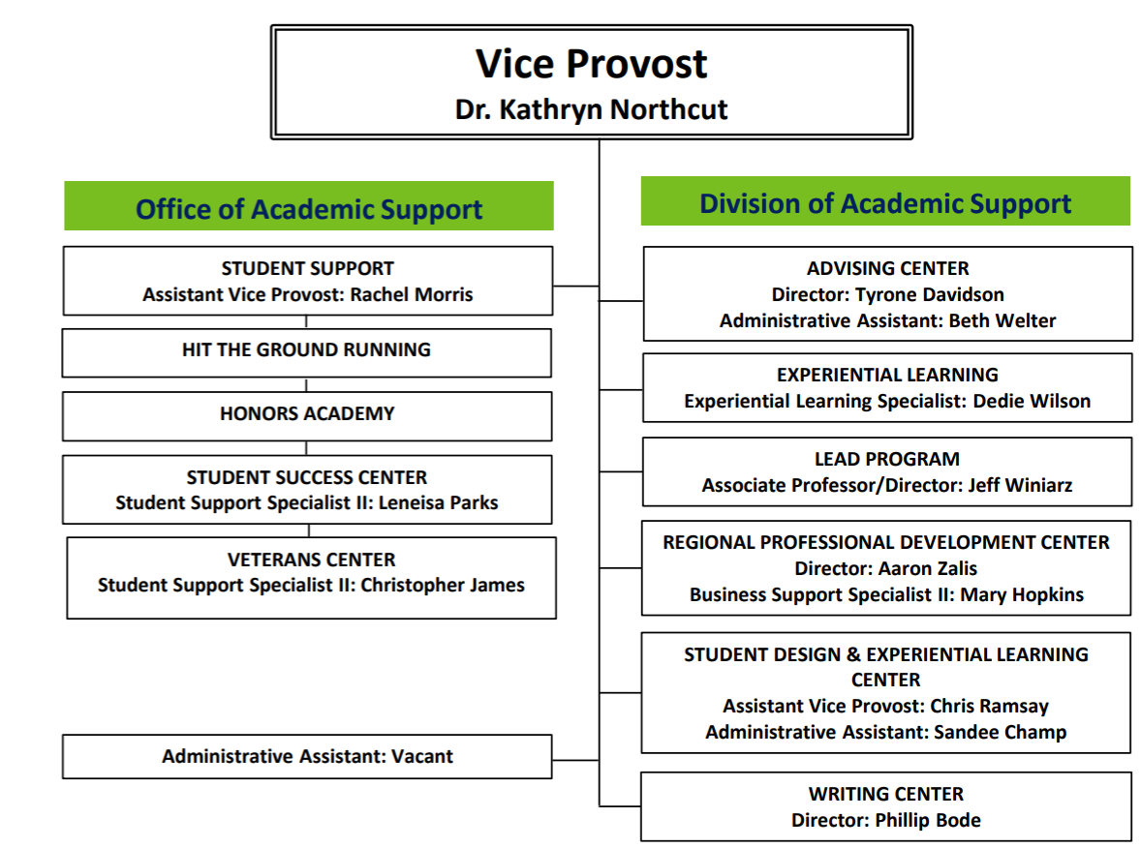
The Vice Provost for Academic Support (VPAS) primary duties include;
- Propose, implement, support efforts to boost UG retention and grad rate (promote LEAD)
- Adjudicate all cases of reported (UG only) academic dishonesty as PAO
- Interface with national organizations: APLU, UERU, NCHC, NSSE, HLC, etc.
- Provide (UG only) retention updates, proposals, & reports to leadership, BoT, BoC, constituencies, campus, system
- Support & advocacy: division office, managers, and staff in departments
- Attend, lead, support committees, activities, ceremonies, events, programs on & off campus
- Assist other divisions and support campus-wide initiatives (recruiting)

VII. Reports of Standing Committees

- Administrative Review Committee
Kelly Homan presented this information during the President’s Report.
- Budgetary Affairs

Mark Fitch presented on behalf of the Budgetary Affairs Committee (BAC). The BAC has addressed the following;
One-time Referrals
- Library budget changes – January report
Continuing referrals:
- Report on the “big picture balance sheet”
- Current and next FY budget
Non-referrals
- Arrival District
- Hiring

For the current FY budget, enrollment revenue was $820K lower than budgeted, so that there is now a $2 million deficit. S&T has a $1 million enrollment contingency, so S&T is still $1 million short.

Numbers for the general revenue budget

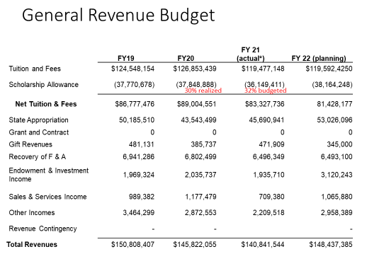

General Revenue Budget: costs

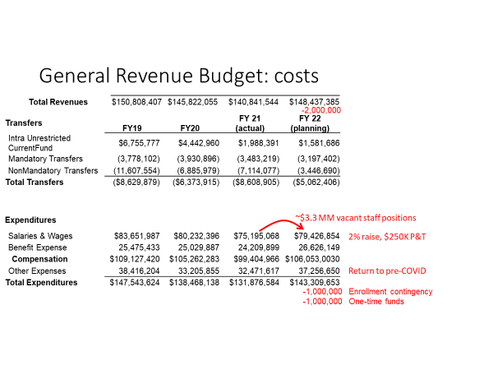

The arrival district costs;
- $18 million and will be funded through donations
- The Protoplex will be funded with gift money and requested state funds
- The plans for a subsurface parking garage will be funded by a gift
- Tim Bradley Way, not to exceed $3.8 million, $2 million will be from a gift
- The past property purchases are on a different fiscal year

The money for hiring looks like this;

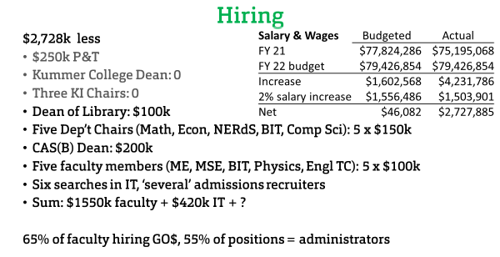

- Curricula
Steve Raper presented on behalf of the Campus Curricula Committee (CCC). The committee met on October 19th. The committee reviewed 6 course change forms, 4 program change forms, and 1 experimental course requests (EC).

The CCC moved for Faculty Senate to approve the 6 course change (CC) forms and 4 program change (PC) forms.
Motion passes.
- Committee for Effective Teaching

Devin Burns presented on behalf of the Committee for Effective Teaching (CET). In a previous meeting, discussion was had about adding questions to the existing survey but that is no longer an option. Instead, the questions will be proposed to the students to get their feedback. The current practice keeps open response comments from the Student Evaluation of Teaching (SET) private to instructors. These comments could provide valuable evidence for accessing teaching effectiveness by chairs and some students feel their complaints are not being heard by the right people. The CET will discuss this next semester so feel free to share your opinions with your representative.

- Library

Kelly Homan presented on behalf of the Library and Learning Resources Committee (LLRC). The Dean of Library position is currently open, and the Provost is interested in a forward-looking vision for the library. Please contact Provost Potts via email with suggestions.

- Public Occasions

Sahra Sedigh Sarvestani presented for the Public Occasions Committee (POC). The POC has two motions today.

The Public Occasions committee moves that October 22 be adopted as the date of Homecoming 2022.

Motion passes.

The Public Occasions committee moves that a separate commencement ceremony be held for Fall 2021 PhD graduates on December 17, 2021.

Motion passes.

VIII. Unfinished Business

IX. New Business

X. Adjourn

The meeting adjourned at 3:18 P.M.

Respectfully submitted,
Dave Westenberg, Secretary

