
Missouri University of Science and Technology

Faculty Senate Meeting

Innovation Lab and Online
20 November 2025


2


Meeting procedure
- Only Senators (or their proxies) present in person count toward a quorum
  - Two-thirds of the voting membership constitutes a quorum
- Only Senators (or their proxies) present in person may vote
- The chair will recognize members of the Senate (including proxies and ex-
officio members) for the purposes of motions and debate
- Members are requested to wait for recognition before speaking
  - Please wait for the microphone

Call to Order

P. Runnion, President


3

Roll Call

F. Han, Secretary

4

Consent Agenda

P. Runnion

5


Consent Agenda – 11/20/2025
6

Curriculum Committee Report

Approval of the 16 October 2025 Minutes

CCC Meeting - 21 Oct 2025

Total Committee Activity
- 9 Course Change Requests (CC Forms)
- 8 Program Change Requests (PC Forms)
- 1 declined
- 10 Experimental Course Requests (EC Forms)

Course Change Requests
File: 507 BUS 5360 : Business Operations File: 1759 CHEM 1310 : General Chemistry I
File: 1636 ENG MGT 6101 : Advanced Research Methodology
File: 10335 ENV SCI 5425 : Environmental Conservation File: 4731 MKT 5410 : Big Data Consumer Analytics File: 994 PSYCH 2200 : Research Methods
File: 10333 THEATRE 2400 : Principles of Stage Management File: 10332 THEATRE 2200 : History of Entertainment Design File: 10334 THEATRE 4243 : Entertainment Design II

Program Changes (DC) Requested
File: 253 AI-MI : Minor in Artificial Intelligence and Machine Learning in Business File: 46 ENG MG-MS : Engineering Management MS
File: 256 FIN TCH-MI : Minor in Financial Technology, Analytics and Transformation File: 58 FINANCE-MI : Finance Minor
File: 70 GLBLSTD-MI : Global Studies Minor File: 75 IST-BS : Information Science and Tch BS File: 136 THEATRE-MI : Theatre Minor
Rolled back to department
File: 131 SYS EN-PHD : Systems Engineering PhD- missing documentation

For Informational Purposes; No Senate Approval Required
Experimental Course (EC) Requested

File: 540 BIO SCI 6001.024: Systems Biology
File: 545 ELEC ENG 2001.004: Emerging Technologies in Semiconductors File: 539 ENG MGT 5001.003: Innovation Ecosystems
File: 544 ENGLISH 3001.054: AI in Popular Culture File: 538 ENV SCI 2001.001: Mammalian Ecology
File: 541 MATH 5001.010: Mathematical Foundations of Deep Learning File: 542 MECH ENG 3001.005: Biomechanics
File: 537 PET ENG 5001.014: Professional Development non-thesis Grad Students File: 536 PET ENG 6001.017: Professional Development Grad Students w Thesis File: 543 STAT 5001.010: Topics in Data Science

Curriculum committee moves for FS to approve the 9 CC form, and 7 PC form action requests.

Discussion: Questions or comments?

President’s Report

P. Runnion

12

IFC Updates – November 17 (Columbia)
- Discussion with President Choi
  - Recent Chronicle article and NPR episode
  - Compact for Academic Excellence in Higher Education
    - All parties involved expressed multiple concerns
    - President Choi will keep IFC in the loop regarding any future developments regarding the compact
  - Budget discussion
    - State revenues are currently down 1.5%, which is actually better than expected
    - We are hoping for state funding in the next fiscal year to be flat or perhaps up very slightly

IFC Updates – November 17 (Columbia)
- Academic Calendar – CRR 20.140
  - Current language: 43 MWF class sessions and 29 TR class sessions per semester
  - Veterans Day (November 11) is now a UM System holiday
  - The added holiday causes S&T and UMSL to be out of compliance with CRR 20.140 every year
and Mizzou to be out of compliance when Veterans Day falls on M, W, or F
    - This is why we had to shorten our Fall Break this year
    - Without CRR changes, S&T and UMSL would need to eliminate Fall Break in Fall 2026
  - Proposed fix: Remove specific number of meeting days

IFC Updates – November 17 (Columbia)
- Academic Calendar – CRR 20.140
  - Current language: The fall semester will begin the first Monday after August 18
  - Since August 18 was a Monday this year, we started on August 25
  - Finals will end on December 19 and grades will be due December 23
    - The Registrar’s Office should not have to work on December 24, 25, and 26 to get grades posted!
  - Proposed fix: Start on the third Monday of August

IFC Updates – November 17 (Columbia)
- Academic Calendar – CRR 20.140
  - Next steps
    - Initial discussion and feedback from all four campuses
    - Revisit at December IFC meeting
    - Possible vote at December 18, 2025 Senate meeting
  - We are hopeful that this can move quickly!

IFC Updates – November 17 (Columbia)
- Digital Accessibility – CRR 600.090
  - Originally adopted in 2022, but regulations change rapidly
  - Modifications to CRR 600.090 are currently being drafted
    - Goal: Make the CRR more nimble as new regulations and standards come into effect
  - No timeline yet for the CRR changes
  - Wide ranging discussion of Title II accessibility requirements
  - Amber Cheek (UM System Director of Accessibility and ADA Coordinator) is willing to present to Senate if we are interested

Faculty Analytics Committee
- Exploring replacements for MyVita system

IT Updates – Classroom Configurations
- Exploring potential new classroom technology configurations
- Toomey 260 – pilot classroom in Spring

Academic Unit Reorganization Process
- Multiple meetings with Provost Harris regarding this document
- Fruitful discussions are ongoing
- Further updates will be provided as they are available

Vice Provost for Enrollment Management
- David Spivey left S&T
- Search committee was formed
- Search was cancelled
- Ashley Crilly is now interim

Space Allocation Committee
- Met on Tuesday November 4
- Consultant report on space utilization was previewed
- The report claims that we have way too many classrooms
  - I disagree with this conclusion

Miner Wall of Fame
- Event scheduled for November 6
- November 1: I received an email indicating Cheryl Schrader would attend
- November 4: I received an email indicating that the event was being postponed
  - No indication of the reason for postponement
- November 5: eConnection announcement regarding postponement
- No further communication about this event since November 5

Tenure Policy Committee
- The TPC requests your feedback as to whether entrepreneurial activity should
be included in P&T packets.
  - Contact a member of the TPC with your feedback!

Bylaws Revisions
- Working group
  - Mike Bruening (History and Political Science), chair
  - Steve Corns (Engineering Management and Systems Engineering)
  - Mike Gosnell (Computer Science)
  - Kelly Liu (Earth Sciences and Engineering)
  - Melanie Mormile (Biological Sciences)
  - Paul Runnion (Mathematics and Statistics)
  - Dave Westenberg (Biological Sciences)

Bylaws Revisions
- Working group held an initial meeting on October 27
- Google form for feedback/suggestions circulated to all faculty
- Working group is making suggested edits

Bylaws Revisions – Some Initial Proposals
- Revision of Tenure Policy Committee charge to remove investigations of
“research misconduct” (conflicts with CRR 420.010)
- Proposing 4 Gen Fac meetings, with time for questions at all of them
- Removing requirement for mail-in ballot for amending bylaws
- NTT roles
  - Making all full-time, ranked faculty and librarians voting members of Gen Fac
  - Allowing committee chairs to be NTT (with exceptions)

Bylaws Revisions – Some Initial Proposals
- Committee restructuring (eliminating 4 committees)
  - Rolling Student Awards and Financial Aid into Student Affairs
  - Rolling Student Conduct, Student Scholastic Appeals, and Tuition and Residence committees into one Student Conduct and Appeals Committee
  - Combining Parking and Environmental Health and Safety into one Safety, Security, and
Parking Committee
  - Adding the Department Chairs Committee (DCC) as a standing committee


Faculty Senate Website
- https://facultysenate.mst.edu/

Campus Reports
A. Staff Council

M. Evans

30

Campus Reports
B. Student Council

A. Pickett

31

Campus Reports

C. Council of Graduate Students

32

Special Topics
  - CFO Presentation

A. O’Neil

33

Missouri University of Science and Technology

Missouri S&T FY26 Financial Update
Budget Update
New Investments Strategic reallocation

Faculty Senate November 20, 2025


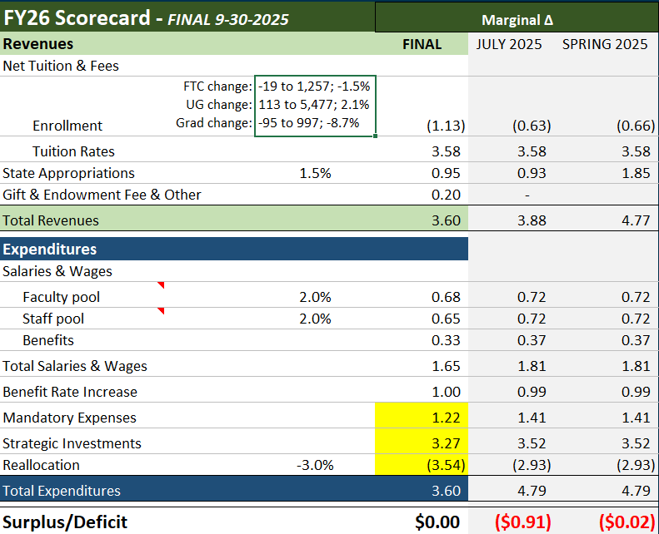
Final Scenario:
…as of 9/30/2025

- First-time college: 1.5% decrease
- New international grad:
  - 5% decrease
  - Intl masters: 117 to 109 (-8)
  - Intl Ph.D.: 76 to 75 (-1)
- Tuition increase:
  - 5% undergraduate
  - 3% graduate
- State: 1.5% increase to base
- $3.54M reallocation

FY2026 Reduction Summary

General Revenue Budget Reductions

Reduction Category | Reduction Amt | FTE Reduction
Frozen/Eliminated Position & Layoffs
Administration | $920,705 | 9
Faculty | $451,025 | 4
Staff | $458,711 | 8
Salary Reserve Pools | $939,890
Non-Personnel Spend Savings | $147,995
Shifting cost to other source | $619,876
Total | $3,538,202 | 21

FY26 Planned Recurring Investments: $3.27M

Strategic Investment | Recurring
Market/Equity Adjustments | 300,000
Faculty lines | 700,000
Supplemental Core Instruction Funds | 440,000
IT Personnel | 275,000
National Visibility/Program specific Marketing | 250,000
AMCL (Core Facility) Annual Operating | 150,000
Promotion & Tenure | 150,000
Enrollment Strategist (1FTE) | 115,000
Research Support in Colleges - Yr 3 of 3 | 100,000
Admissions E&E | 100,000
Athletics shortfall | 100,000
Library Acquisitions | 100,000
Desktop Enhancement | 25,000
Post Tenure Award | 25,000
On-line programs shortfall | 200,000
VP and Dean of Graduate Education & Postdoctoral Studies | 233,350

FY26 One-time Investments

Description | FY25 | FY26 | SFA
Faculty startup | 1,000,000 | 800,000 | 4
IT needs - Infrastructure, classroom, labs, research | 700,000 | 700,000 | 4
Teaching lab equipment/Space upgrades | 500,000 | 500,000 | 3
Research equipment maintenance | 300,000 | 400,000 | 4
Supplemental core instruction | 300,000 | 300,000 | 3
Student success & retention | 300,000 | 300,000 | 2
Marketing - National visibility | 250,000 | 200,000 | 5
Marketing - Academic program specific | - | 200,000 | 5
Dual career hires support | 200,000 | 200,000 | 7
On-line education program expansion | 300,000 | 150,000 | 3
PhD recruitment |  | 100,000 | 4
Staff and Faculty mentor & leadership programs | - | 75,000 | 7
Space utilization strategy | 500,000 | - | 8
High traffic space and furniture refresh | 412,000 | - | 8
BI & Process improvement | 100,000 |  | 7
Total | 4,862,000 | 3,925,000

FY2026 Budget – Operating Revenues
All University Funds (in millions)

 | FY2024 | FY2025 | FY2026 | $ Δ | % Δ
 | Actuals | Actuals | Projection Current
Operating Revenues
Tuition and Fees | $134.6 | $142.1 | $149.2 | $7.1 | 5%
Less Scholarship Allowances | $76.8 | $84.0 | $86.6 | $2.5 | 3%
Net Tuition and Fees | $57.9 | $58.1 | $62.7 | $4.6 | 8%
Institutional Discount Rate | 57.02% | 59.12% | 58.00%
Federal Pell Grants | $6.7 | $8.6 | $8.1 | -$.4 | -5%
Government Scholarship Funding | $6.0 | $6.0 | $6.0 | $.0 | 0%
Grants and Contracts | $55.1 | $63.0 | $63.7 | $.7 | 1%
Auxiliary Enterprises | $28.1 | $31.5 | $33.4 | $1.9 | 6%
Other Operating Revenues | $4.3 | $5.4 | $4.6 | -$.8 | -15%
State Appropriations | $60.1 | $62.0 | $62.9 | $.9 | 2%
Private Gifts | $19.6 | $20.8 | $22.5 | $1.7 | 8%
Spendable Investment Income (Internal) | $14.6 | $15.3 | $15.8 | $.5 | 3%
Total Operating Revenues | $252.5 | $270.6 | $279.7 | $9.1 | 3%

FY2026 Budget – Operating Expenses
All University Funds (in millions)

 | FY2024 | FY2025 | FY2026 | $ Δ | % Δ
Operating Expenses | Actuals | Actuals | Projection Current
Salaries and Wages | $115.7 | $127.2 | $133.6 | $6.4 | 5%
Benefits | $35.1 | $39.0 | $43.3 | $4.3 | 11%
Supplies, Services and Other Operating Expenses | $62.4 | $61.6 | $64.0 | $2.4 | 4%
Depreciation | $25.4 | $26.7 | $27.4 | $.6 | 2%
Interest Expense | $4.8 | $4.6 | $4.5 | -$.1 | -3%
Total Operating Expenses | $243.4 | $259.2 | $272.8 | $13.6 | 5%
Net Operating Income | $9.1 | $11.4 | $7.0 | -$4.4 | -39%
Net Operating Margin | 3.6% | 4.2% | 2.5%

FY2026 Budget – Non-Operating Revenues (Expenses)

All University Funds (in millions)

Non-Operating Revenues (Expenses) | FY2024  Actuals | FY2025  Actuals | FY2026  Projection Current | $ Δ
Investment Income (Losses), Net of Fees | $29.7 | $26.9 | $22.1 | -$4.8
Spendable Investment Income (Internal) | -$14.6 | -$15.3 | -$15.8 | -$.5
Other Non-Operating Revenues (Expenses) | -$1.3 | $3.3 | -$1.1 | -$4.4
State Capital Appropriations | $5.0 | $7.2 | $28.1 | $21.0
Capital Gifts and Grants | $32.2 | $94.8 | $55.0 | -$39.7
Private Gifts for Endowment Purposes | $5.7 | $10.8 | $14.8 | $4.0
Mandatory Transfers | $0.0 | $0.1 | $0.0 | -$.1
Non-Mandatory Transfers | $0.3 | $6.1 | $0.0 | -$6.1
Net Nonoperating Revenues (Expenses) | $56.9 | $133.9 | $103.2 | -$30.7
Increase in Net Position | $66.0 | $145.3 | $110.1 | -$35.2

Missouri University of Science and Technology

Missouri S&T FY26 Financial Update
Budget Update
New Investments Strategic reallocation

Faculty Senate November 20, 2025

Committee Reports
  - Administrative Review

K. Erickson

43


Agenda

Reports of Standing Committees

Administrative Review
K. Erickson

2025-2026 Members

- Kelvin Erickson, Chair
- Bih-Ru Lea
- Kelly Liu
- Jorge Porcel
- Matt Thimgan

Faculty Bylaws
“Administrative Review Committee
  - This committee sets policies and procedures for review of campus administrators. The committee recommends the evaluation questionnaires and a plan/schedule for conducting reviews to the Faculty Senate. The committee conducts the reviews; oversees the sending of the evaluation forms to the evaluating persons; oversees the collection and collation of the resulting evaluations; and, along with the officers of the Faculty Senate, reviews and forwards the results of the evaluation.
  - The committee consists of four (4) representatives nominated by the Rules, Procedures and Agenda Committee (with the possibility of nominations from the floor) and elected by a vote of the Faculty Senate. Committee members serve for two (2) years, terms to be staggered with the election of two faculty members each year, and shall be full-time, tenured faculty members with an administrative component of 50% or less.”

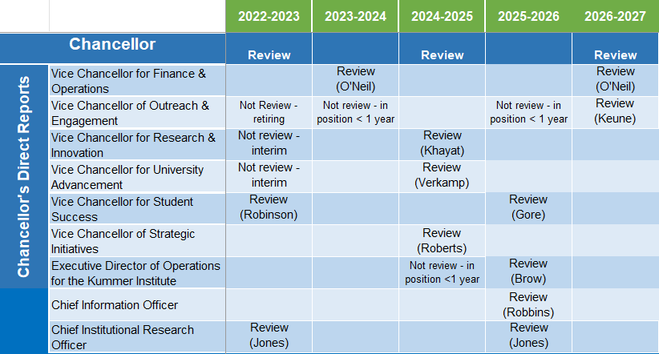

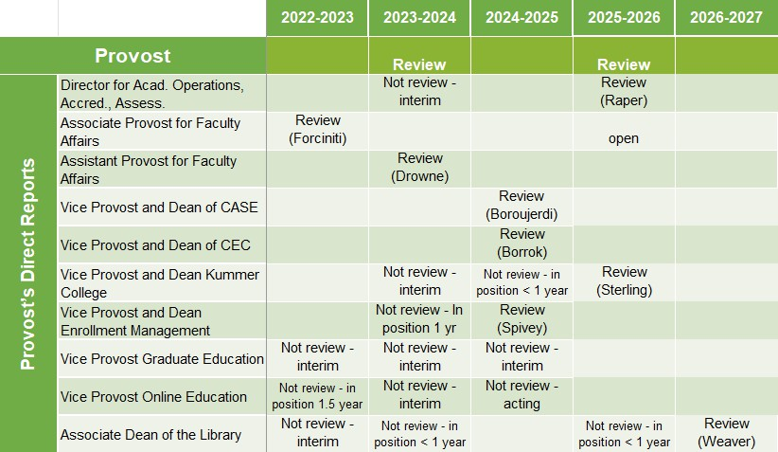

Missouri University of Science and Technology

Positions Suggested for Review
- Vice Chancellor for Student Success (Gore)
- Executive Director of Operations for the Kummer Institute (Brow)
- Chief Information Officer (Robbins)
- Chief Institutional Research Officer (Jones)
- Provost (Harris)
- Director for Academic Operations, Accreditation, and Assessment
(Raper)
- Vice Provost and Dean Kummer College (Sterling)

Positions Not for Review
- Executive Director: Marketing and Communications: < 1 yr
- Associate Provost for Faculty Affairs: open
- Dean/Director of the Library: < 1 yr

Faculty Senate Motion
The Administrative Review Committee moves the following:
The Administrative Review Committee recommends that the following administrative positions be reviewed in the 2025-2026 cycle:
Vice Chancellor for Student Success (Gore)
Executive Director of Operations for the Kummer Institute (Brow) Chief Information Officer (Robbins)
Chief Institutional Research Officer (Jones)
Provost (Harris)
Director for Academic Operations, Accreditation, and Assessment (Raper) Vice Provost and Dean Kummer College (Sterling)

Tentative Timeline and Process

Missouri University of Science and Technology

Action | Time
Review list to faculty senate for approval | November 20, 2025
Job descriptions | Nov/Dec 2025
Development of questionnaires
Questionnaires to FS for review/approval | December 18, 2025
Statement of accomplishments due | February, 2026
Review of administrators | March 9 - March 20
Results to FS officers | Early May
Results shared with reviewees | Late May
Final report to FS | June 18

Committee Reports
B. Budgetary Affairs

B. Lea

53

Missouri University of Science and Technology

Budgetary Affairs Committee

Academic Year: 2025 - 2026

Report To Faculty Senate: 11-20-2025

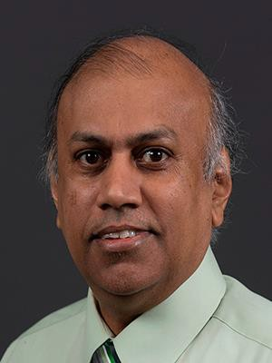
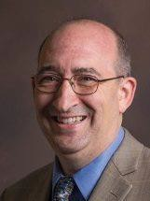
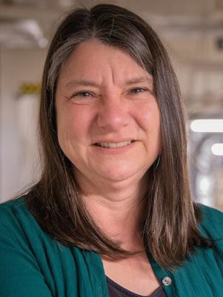
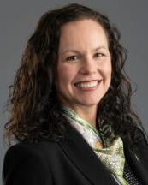

Budgetary Affairs Committee (BAC) Members
11-20-2025 Report

E
- Financial Position
Update
- Referral Follow-Up: Faculty Composition and Investment to Sustain R1 Status
- Ongoing Referrals
CFO Alysha O'Neil
D
Dr. Melanie Mormile
D
Dr. David Bayless
D
Dr. Jag Sarangapani
D
Dr. Michael Meagher

alysha.oneil@mst.edu mmormile@mst.edu dbayless@mst.edu,
sarangap@mst.edu,
mmeagher@mst.edu,

Finance & Operations
CASE
CEC
CEC
CASE

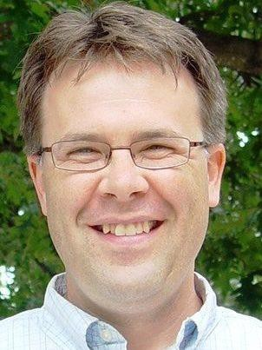
FS
Dr. Kelly Homan
FS

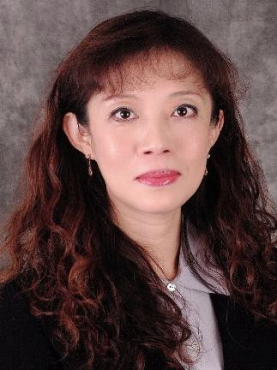
Dr. Bih-Ru Lea
G
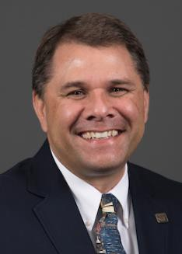
Dr. Michael Moats

Graduate Faculty
StuC

Mr. Logan Garton

G

khoman@mst.edu, CEC
leabi@mst.edu, Kummer
moatsm@mst.edu CEC
Council
wgcf2@mst.edu Student Council, Civil Eng

Financial Position Update

CFO Alysha O’Neil Special Topic Report
- FY 27 Budget and five-year long-range plan are currently in development
  - CFO Alysha O’Neil to present updated long-range plan to UM System in December to be included with system-wide long-range plan for Board approval
  - BAC and/or CFO will provide the FY 27 Budget
updates at the February 12 Faculty Senate Meeting
  - CFO can review the draft FY 27 scorecard planning
scenarios as early as February dependent on Faculty
Senate availability

Send questions, feedback, ideas suggestions, …



https://tinyurl.com/FS-referrals

Special Topic:

Missouri University of Science and Technology
Background Info
(on-going) Provide feedback on the budgetary priorities that ensure adequate faculty investment based on the salary trends and position numbers of faculty and executives

Provost Harris’ Vision and Plans on Faculty Investment

Provost Harris was invited to the November 5 Budgetary Affairs Committee Meeting to share his vision and plan to sustain R1 Status in the following two areas:
  - Faculty Hiring Direction and Budget Strategies for new faculty hiring
  - Faculty Incentive Program and Budget
Alignment

Stated Priorities on Programs/Initiatives
Preferences for programs and initiatives that
… have faculty support
… are self-sustainable and financially responsible
… are externally funded
… require a lower level of funding

Background Info
With the observed decreasing trends in tenured/tenure-track faculty (T/TT), the needs to (1) balancing Faculty compositions and (2) new funding models to support research T/TT faculty

Missouri University of Science and Technology

Stated Priorities and Ideas on Programs/Initiatives
- Enrollment increase has a positive relationship with increasing faculty lines for Tenured/Tenure-Track (T/TT) Faculty
- Tenured/Tenure-Track Faculty with funded Ph.D.
Student Support (initial idea, input welcome)
  - Target numbers per faculty
    - Full professor: 5

    - Associate professor: 4
    - Assistant professor: 3
  - Funding sources: externally funded
https://tinyurl.com/FS-referrals

Ideas on Ph.D. Student Enrollment Initiatives and Programs
- Dual Ph.D. program with other universities
Ongoing discussions with universities in Europe (Dr. Kamal Khayat) and

India (Dr. Sajal Das)
- Domestic Ph.D. Student Incentives, including the tuition waivers, and the feasibility of securing external grants and funding
- Development of a sustainable and competitive Ph.D. student funding model, including subsidies for tuition, insurance, and other essential support.
- Exploration of online Ph.D. program offerings that enhance research quality
- Review of whether R1 Status metrics for Ph.D. student counts include (1) Doctor of Engineering and (2) Doctor of Business Administration (DBA)
- Faculty engagement and input, including sharing professional contacts

Provide Input …

and Ph.D. student recruitment strategies https://tinyurl.com/FS-referrals

Faculty Research Incentive Programs in Development

Tenured/Tenure-Track (T/TT) faculty with grants/proposals responsibilities
  - Provide (1) additional summer salary by extending the current 3-month salary limit and
(2) a bonus during the academic year supported
through external grants
  - Encourage faculty to secure funding for Ph.D. Student through external grants/proposals

Provide input, actionable plans,
…

https://tinyurl.com/FS-referrals

Tenured/Tenure-Track (T/TT) with research publication responsibilities (e.g., non-grants/proposal writing, no Ph.D. program, no master’s program)
  - Teaching release that does not incur cost
  - Faculty and departments are encouraged to propose incentive programs that meet the preferences stated previously
  - Encourage non Ph.D. granting programs to investigate the feasibility of establishing one to

Feeback & Suggestions

elevate research. https://tinyurl.com/FS-referrals

Non-Tenure Track (NTT) Faculty with primary teaching responsibilities

  - Ideas, suggestions, actionable plans, and proposals are welcome

https://tinyurl.com/FS-referrals

Develop sustainable enrollment incentive programs that provide additional resources to support new faculty lines, research activities, and teaching needs
  - Programs should be Self-sustaining and financially responsible
  - Example: Revenue sharing model (e.g., modified or delta RCM* model)

Have ideas, questions, suggestions, …

*RCM: Responsibility Center Management
https://tinyurl.com/FS-referrals

Ongoing Referrals scheduled for the Next BAC Meeting
- FY 27 Budget Update

- Feasibility of establishing a central budget line item within the university’s operating budget to cover essential services
- Update on Net Revenue per Student for (1) Ph.D. students considering 4% increase in graduate stipend, (2) distance tuition model, and (3) New Tuition Model.
- Student Council communicates students’ needs regarding expanding library access hours during peak academic periods, such as exams, for consideration in budget planning and resource allocation.

Have questions,
need referrals, …

https://tinyurl.com/FS-referrals

Information: Next Topic Request Due Date: 11:59 pm, 12-08-2025
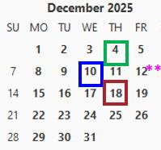
- All topics or questions submitted by Dec. 8 will be reviewed at the Dec. 10 BAC meeting, where the BAC will assess the following
  - Urgencies and priorities of topics/questions
  - data collection timeline
  - Approach(es) to addressing each topic
  - communication plans

 Faculty Senate Meeting  Budgetary Affairs Meeting  RP&A Meeting
** last day of a semester
https://tinyurl.com/FS-referrals
- Findings will then be communicated to the faculty during the Dec. 18 Faculty Senate meeting, another future meeting, or an appropriate communication channel.

Unfinished Business

P. Runnion

67

New Business

P. Runnion

68

69

Motion from Public Occasions
- The Public Occasions Committee moves that October 17, 2026 be designated as
Homecoming.

Q&A with Provost

J. Harris

70

Announcements

P. Runnion

71

72

General Faculty Meeting
- Tuesday December 2, 4:00 PM
- Hasselmann Alumni House

Adjourn

73

P. Runnion
Thank You
President, Faculty Senate

facultysenate.mst.edu

